**Olympic History: Athletes and Results SQL Script Result**

**Questions/Answers**

#### **How many Olympics games have been held?**

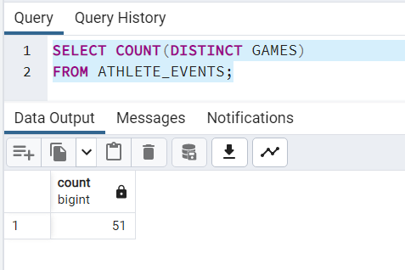

#### **List down all Olympics games held so far.**

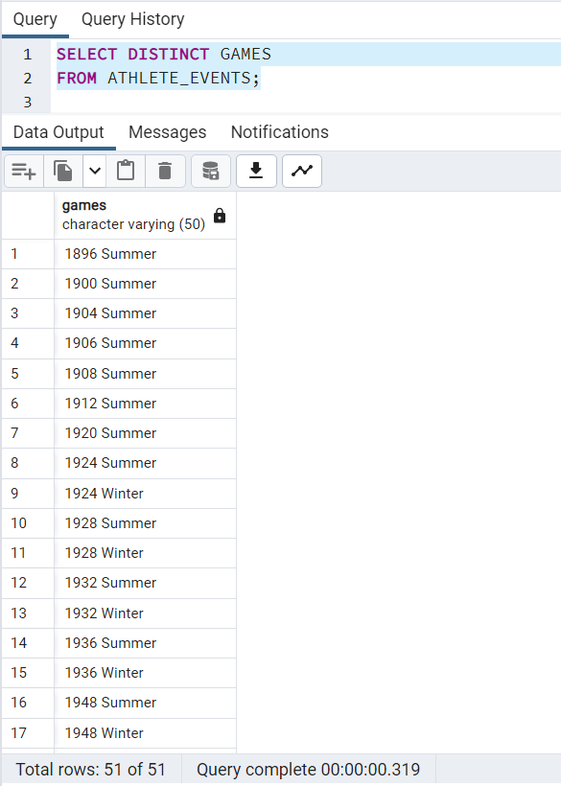

OR

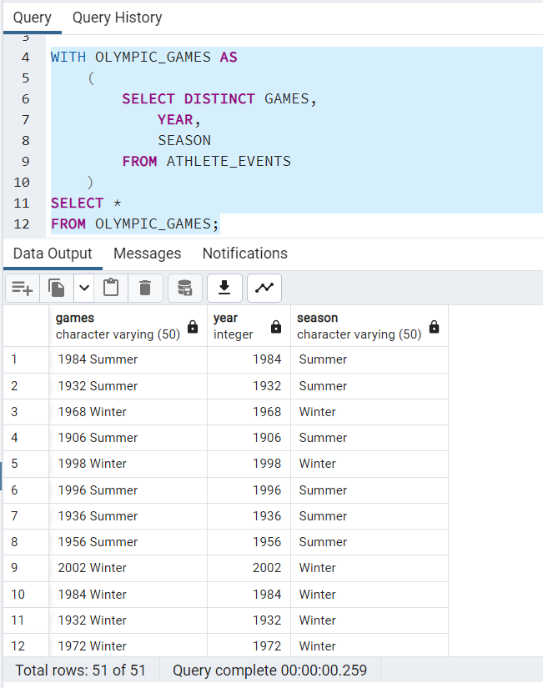

#### **Mention the total no of nations who participated in each Olympics game?**

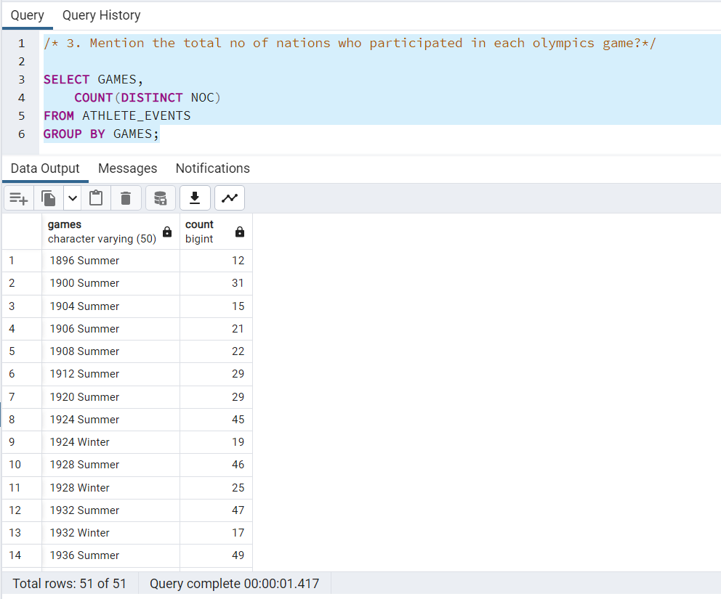

#### **Which year saw the highest and lowest no of countries participating in Olympics?**

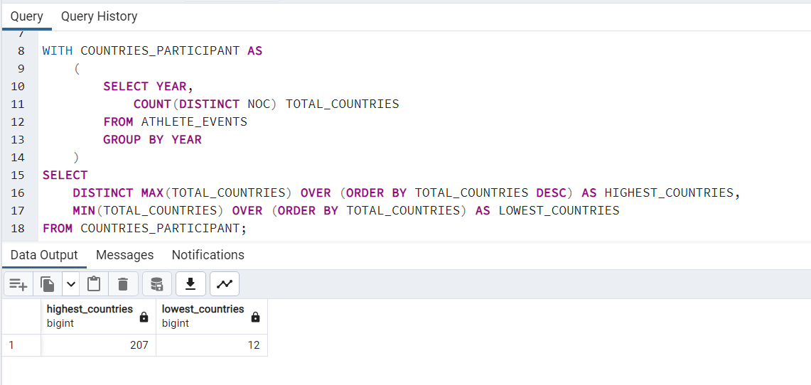

#### **Which nation has participated in all the Olympic games?**

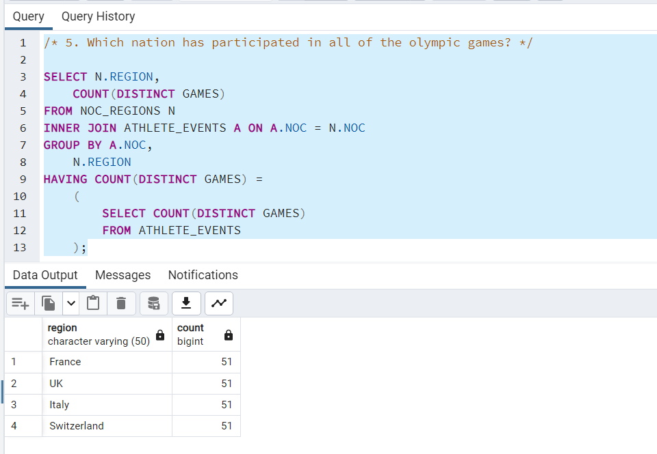

OR 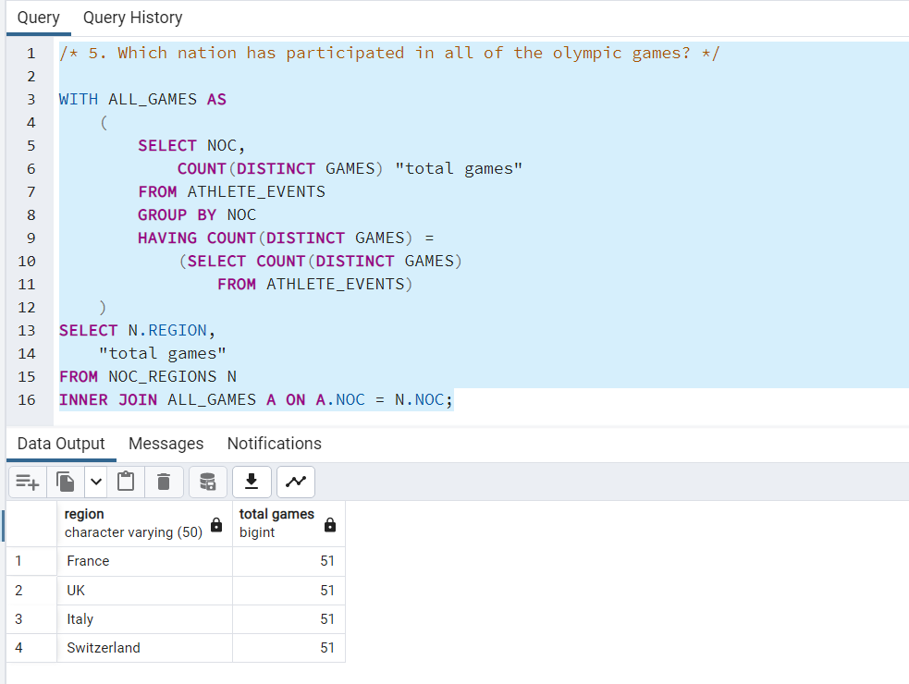

#### **Identify the sport which was played in all summer Olympics.**

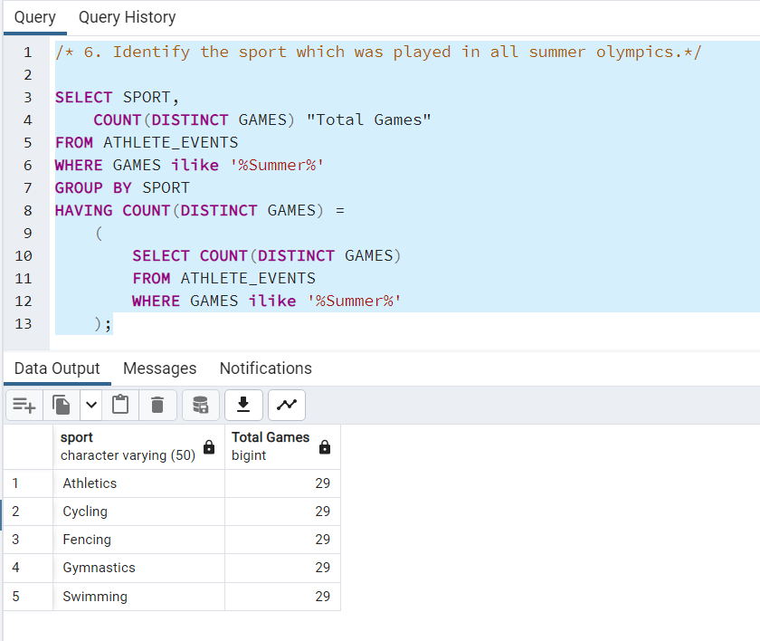

#### **Which Sports were just played only once in the Olympics?**

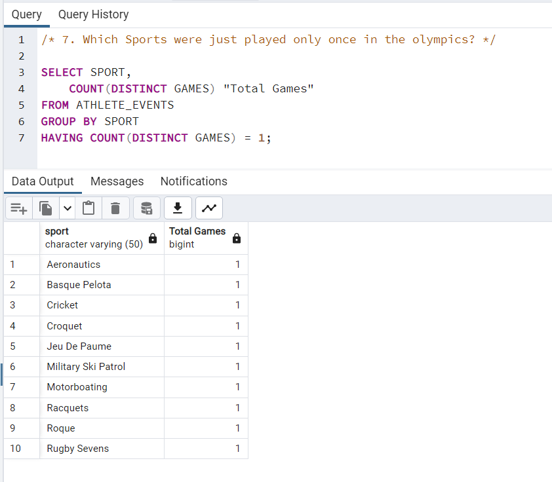

#### **Fetch the total no of sports played in each Olympic game.**

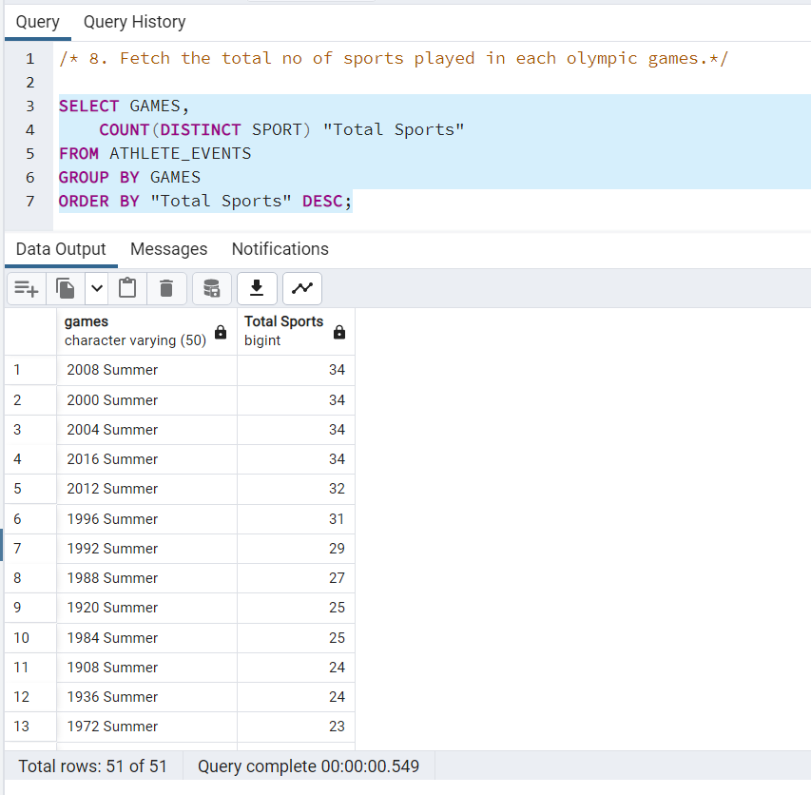

#### **Fetch details of the oldest athletes to win a gold medal.**

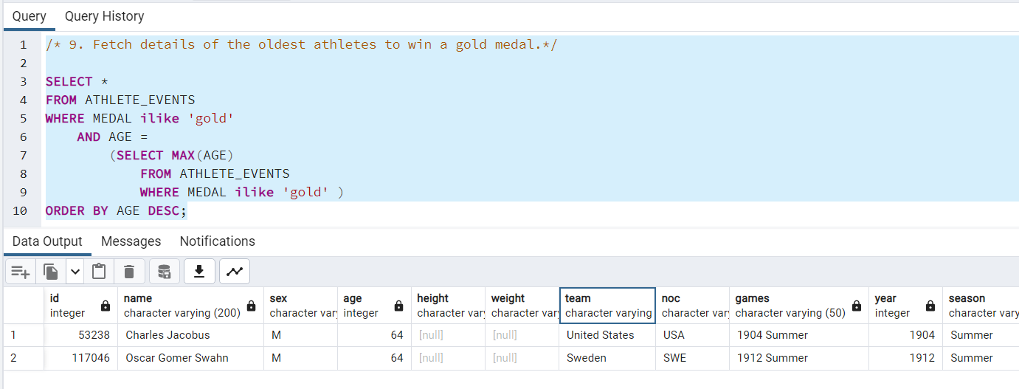

#### **Find the Ratio of male and female athletes participated in all Olympic games.**

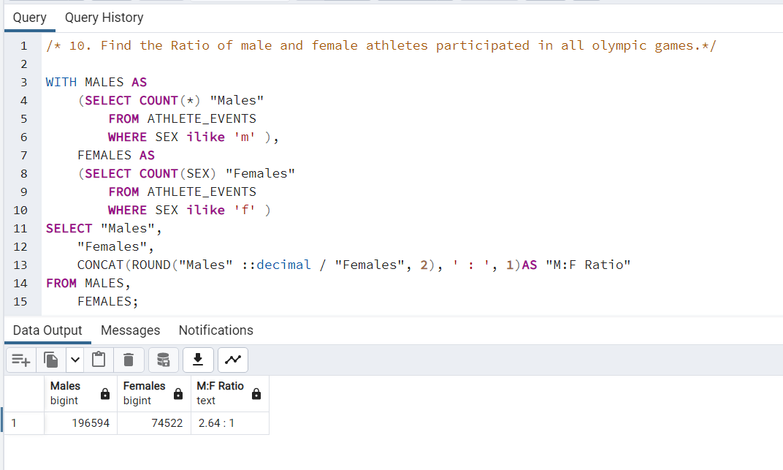

#### **Find the Ratio of male and female athletes participated in each Olympic game.**

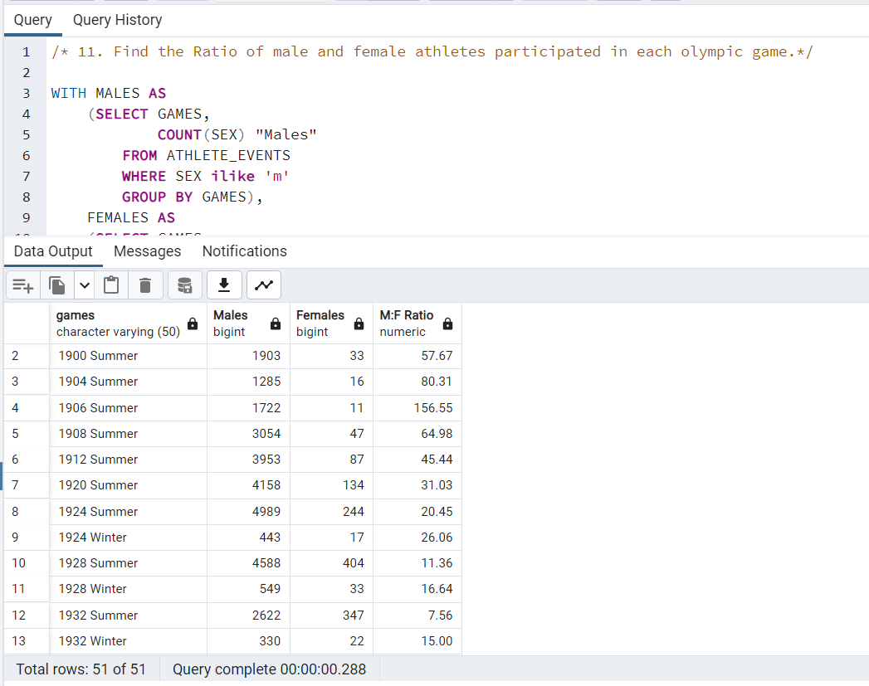

#### **Fetch the top 5 athletes who have won the most gold medals.**

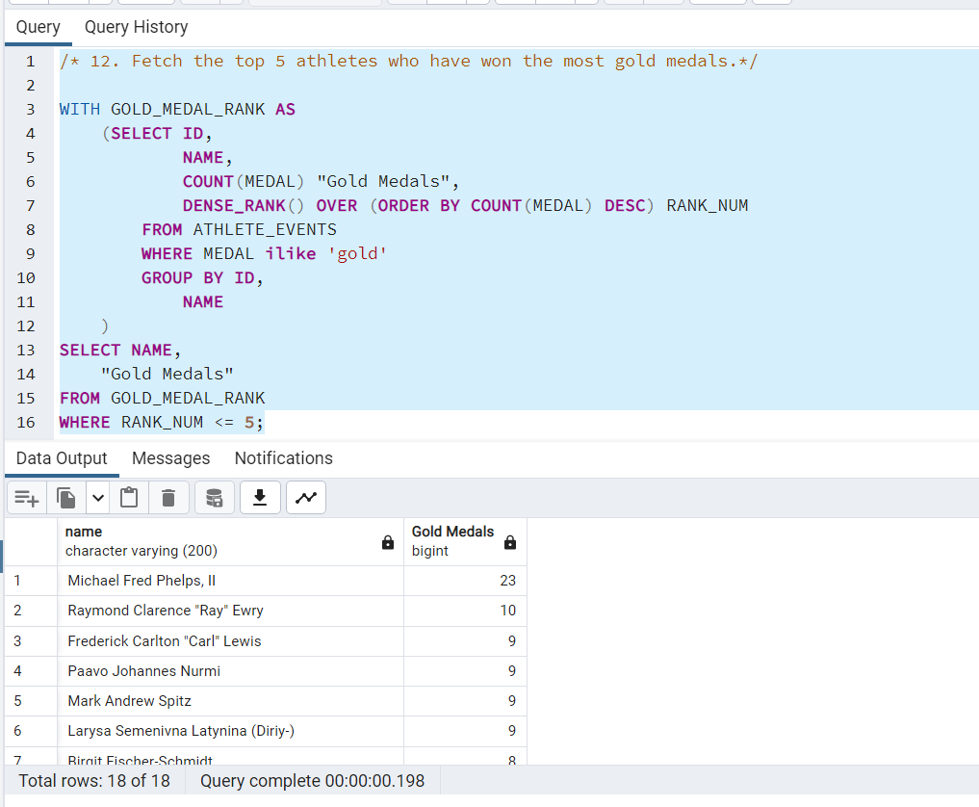

#### **Fetch the top 5 athletes who have won the most medals (gold/silver/bronze).**

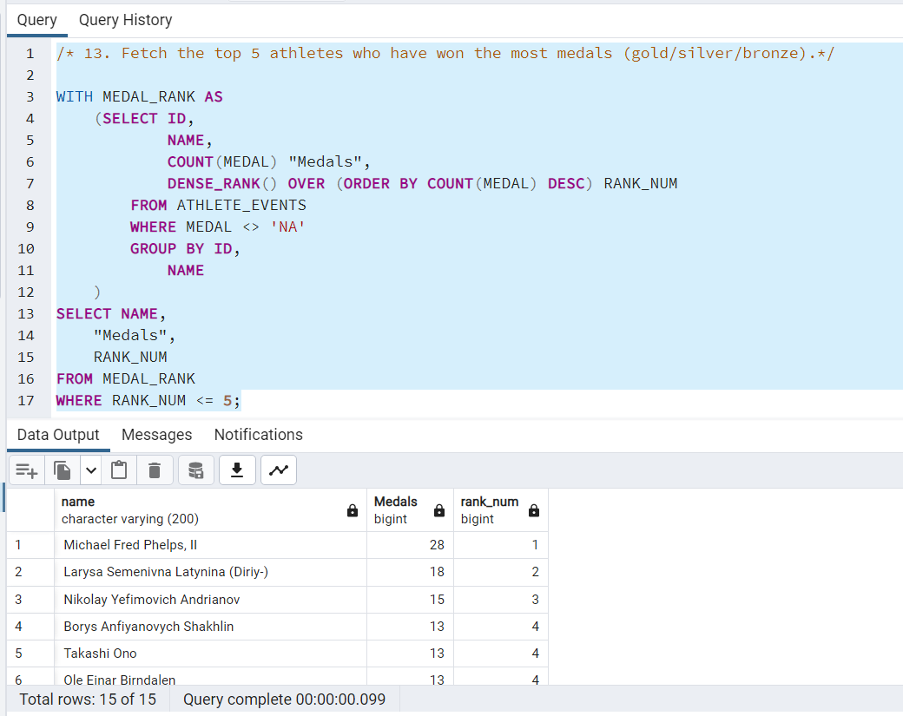

#### **Fetch the top 5 most successful countries in Olympics. Success is defined by no of medals won.**

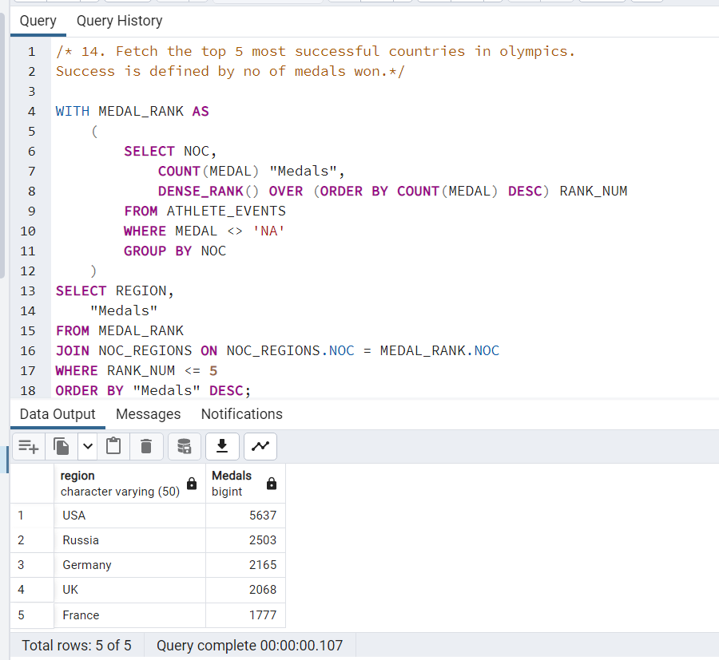

#### **List down total gold, silver and bronze medals won by each country.**

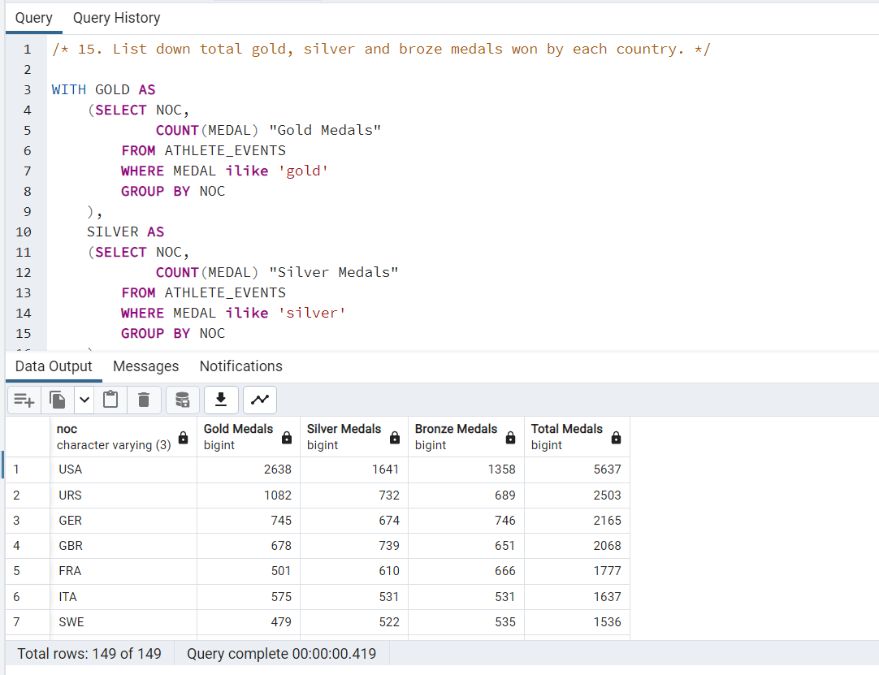

#### **List down total gold, silver and bronze medals won by each country corresponding to each Olympic game.**

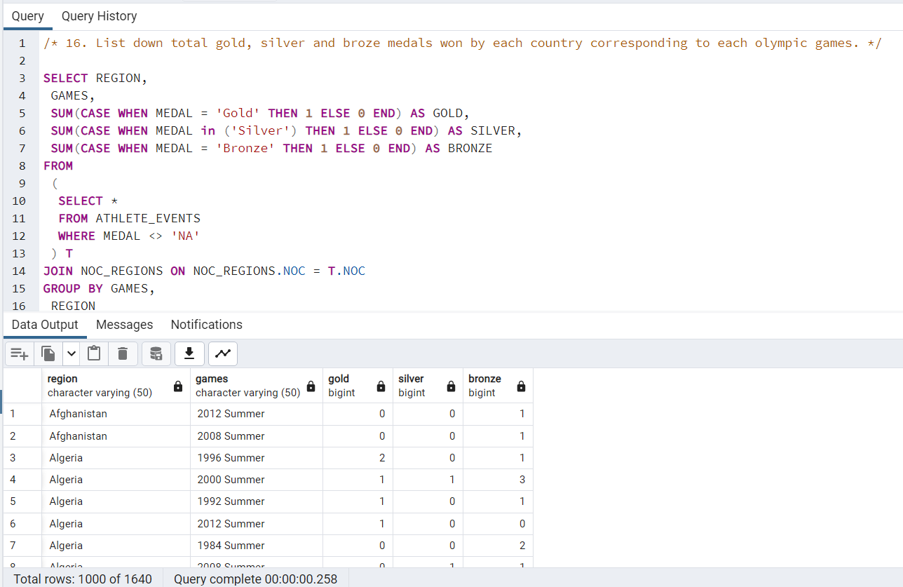

#### **Identify which country won the most gold, most silver, and most bronze medals in each Olympic game.**

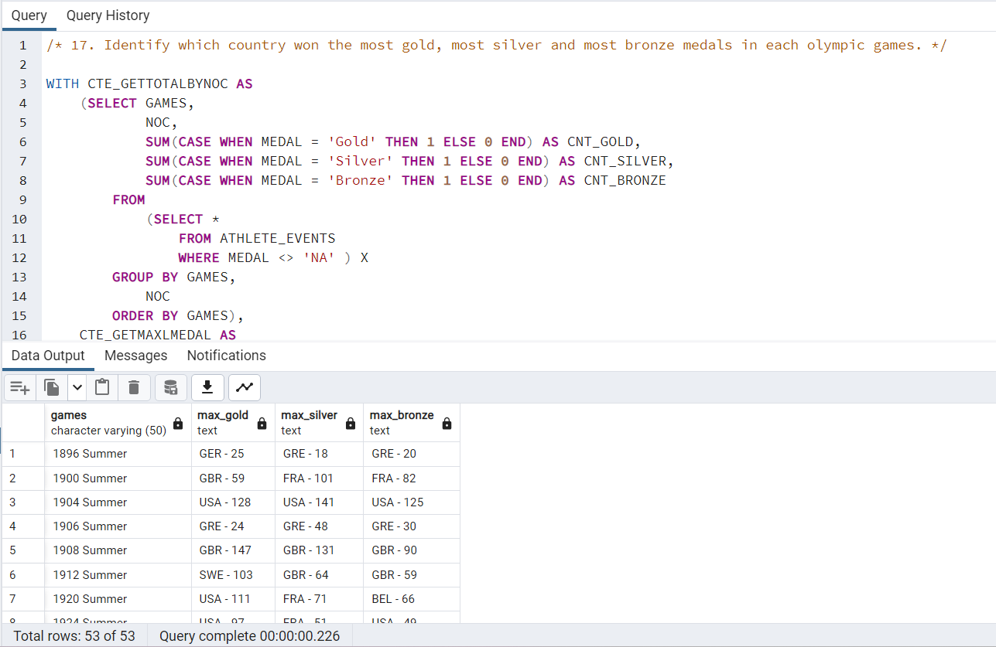

#### **Identify which country won the most gold, most silver, most bronze medals and the most medals in each Olympic game.**

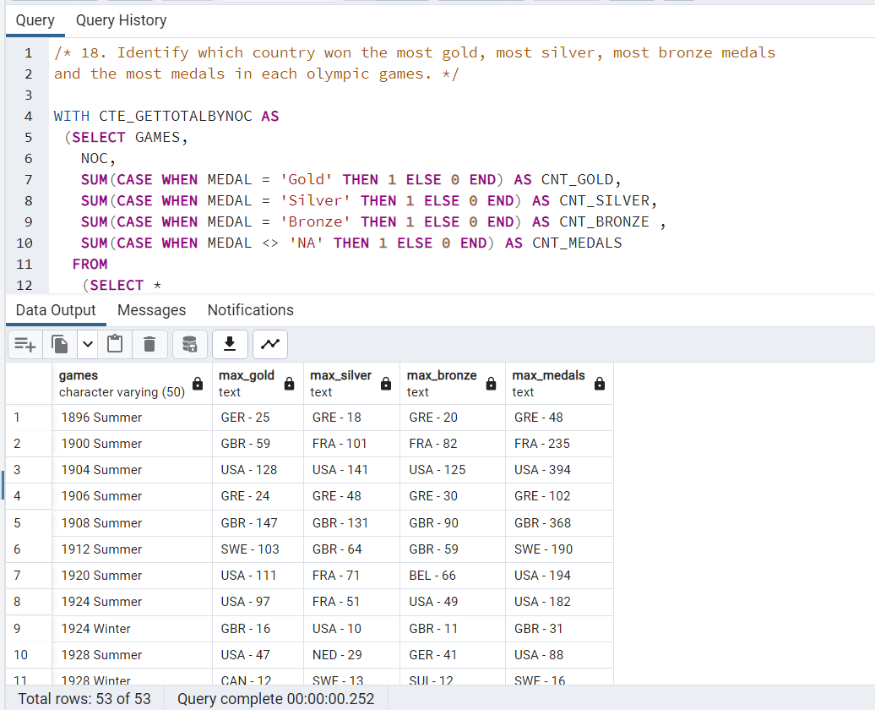

#### **Which countries have never won gold medal but have won silver/bronze medals?**

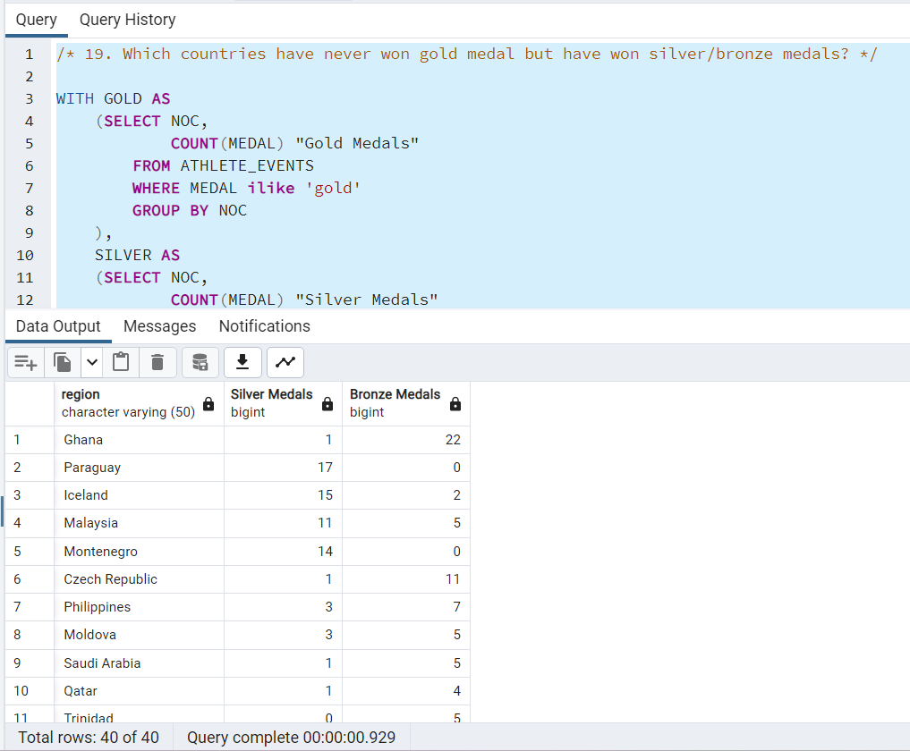

#### **In which Sport/event, India has won highest medals?**

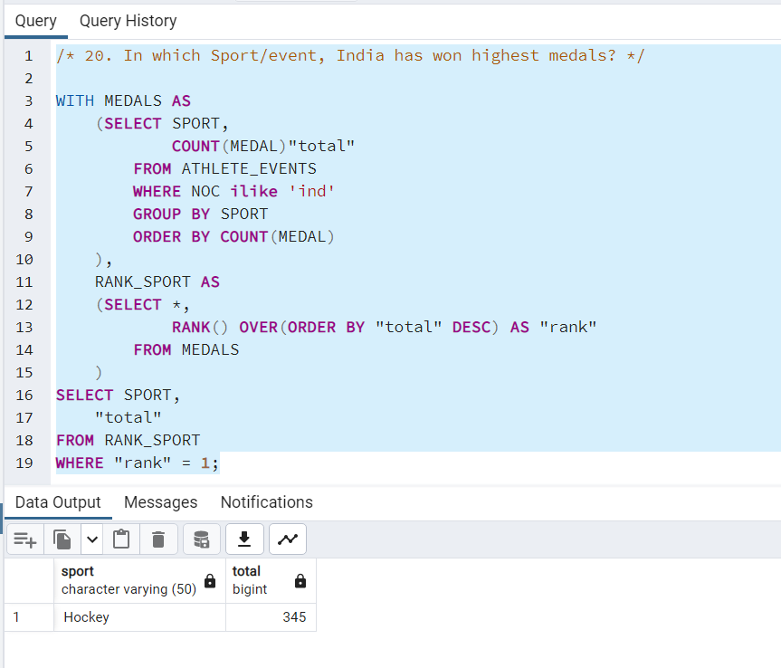

#### **Break down all Olympic games where India won medal for Hockey and how many medals in each Olympic game.**

